

## PES UNIVERSITY

**(Established under Karnataka Act No. 16 of 2013)**

**100-ft Ring Road, Bengaluru – 560 085, Karnataka, India**

***Report on***

**Dynamic Gait Generation for a Humanoid**

**Using Stereo Vision**

***Submitted by***

**Anjana MN (01FB16EEC040)**

**Ashwathi Subramanian (01FB16EEC051)**

**Athindra Bandi (01FB16EEC054)**

## 

## Jan - May 2020

***under the guidance of***

**Prof. M Rajasekar**

**Associate Professor**

**Department of ECE**

**PES University**

**FACULTY OF ENGINEERING**

**DEPARTMENT OF ELECTRONICS AND COMMUNICATION ENGINEERING**

**PROGRAM B.TECH**

**CERTIFICATE**

*This is to certify that the Report entitled*

**Dynamic Gait Generation for a Humanoid Using Stereo Vision**

*is a bona fide work carried out by*

**Anjana M N (01FB16EEC040)**

**Ashwathi Subramanian (01FB16EEC051) Athindra Bandi (01FB16EEC054)**

In partial fulfillment for the completion of 8th semester course work in the Program of Study B.Tech in Electronics and Communication Engineering under rules and regulations of PES University, Bengaluru during the period Jan – May 2020. It is certified that all corrections/suggestions indicated for internal assessment have been incorporated in the report. The report has been approved as it satisfies the 8th semester academic requirements in respect of project work.

|  |  |  |
| --- | --- | --- |
| *Signature with date & Seal*  *Prof. M Rajasekar*  *Internal Guide* | *Signature with date & Seal*  *Dr. Anuradha M*  *Chairperson* | *Signature with date & Seal*  *Dr. B K Keshavan*  *Dean – Faculty of Engg. & Tech.* |

Name and signature of the examiners:

1.

2.

3.

# 

# 

# 

# DECLARATION

I, **,** hereby declare that the report entitled, ‘***Dynamic Gait Generation for a Humanoid Using Stereo Vision’,*** is an original work done by me under the guidance of **Prof. M Rajasekar**, Associate Professor of ECE Department, PES University, and is being submitted in partial fulfillment of the requirements for completion of 8th Semester course work in the Program of Study B.Tech in Electronics and Communication Engineering.

**PLACE: BENGALURU**

**DATE: DD MMM YY**

**NAME AND SIGNATURE OF THE CANDIDATE**

# 

# ABSTRACT

A humanoid robot that is bipedal can be suitable to act as an assistive robot functioning in the human environment. However, the bipedal walk can be very complicated. Just walking on an even floor with absolutely zero inclination and evenness is not satisfactory for the applicability of a bipedal humanoid robot. In this report, we will be presenting a study of bipedal walk on irregular surfaces. The gaits of the existing humanoid models are made to adjust dynamically according to the irregularities in the path. The simulation of the same is carried out on a simulation environment, Gazebo. A 34-degrees-of-freedom (DOF) bipedal humanoid model is used in the Gazebo 3-D simulations. These simulations are carried out on an even floor and inclined surface like stairs of a fixed slope value. The humanoid model comes with an in-built stereo vision module that helps it detect the presence of obstacles around it and the slope value is computed using the simple co-ordinate geometry. This value is provided as an input the servos for the corresponding adjustment of the gaits, without any explicit programming involved.

# 

# ACKNOWLEDGEMENT

I take this opportunity to express my profound gratitude and deep regards to my guide Prof. M Rajasekar, Associate Professor of ECE Department, PES University, for his exemplary guidance, monitoring and constant encouragement throughout the course of this project. The blessings, help and guidance given by him from time to time shall carry me a long way in the journey of life on which I am about to embark.

I would also like to express my gratitude to Mr. Prasanna V for his constant guidance and assistance during the course of this project.

I also take this opportunity to express a deep sense of gratitude to Dr. Anuradha M, Chairperson, Department of ECE, PES University, for her unconditional support, valuable information and guidance, which helped me in completing this project work through its various stages.

I would also like to extend my gratitude to Dr. Surya Prasad J, Vice Chancellor, PES University for his support.

# CONTENTS

**1. INTRODUCTION** 8

1.1 Static vs Dynamic Walking 8

1.2 Humanoid Robots of the Future 10

**2. PROBLEM STATEMENT** 13

2.1 Motion Planning in Humanoids 13

2.2 The Goal 14

**3. LITERATURE SURVEY** 15

3.1 Few Definitions 15

3.2 Inverse Kinematics 16

3.3 3D Linear Inverted Pendulum Model 17

3.4 Gait Planning 19

3.5 Simulation Results 22

3.6 Stereo Vision 23

**4. IMPLEMENTATION USING ROS** 25

4.1 ROS Concepts 25

4.2 About HRP-4 27

4.4 Our Simulation 30

4.5 Hardware Implementation 31

**5. RESULTS AND DISCUSSION** 32

**6. CONCLUSION** 34

**7. REFERENCES** 35

**APPENDIX** 36

**LIST OF FIGURES**

|  |  |  |
| --- | --- | --- |
| **Fig 1.1** | Implementation of stereo vision on a humanoid | 10 |
| **Fig 1.2** | Pictures of ASIMO, HRP, Nao, Marty, Kondo KHR 3HV, Kondo KHR 3HV and Pepper | 12 |
| **Fig 2.2** | Dynamic walking | 14 |
| **Fig 3.1** | Image to explain CoM, ZMP and Support Polygon | 16 |
| **Fig 3.2** | Forward and Inverse Kinematics | 16 |
| **Fig 3.3(a)** | Approximation of a biped humanoid robot as 3D inverted pendulum | 17 |
| **Fig 3.3(b)** | Foot placements to determine step length and the step width | 18 |
| **Fig 3.5** | 3d LIP Trajectory | 22 |
| **Fig 3.6** | Illustration of Stereo Geometry | 24 |
| **Fig 4.2** | HRP-4 humanoid | 28 |
| **Fig 4.4** | Screenshot from the simulation | 30 |
| **Fig 4.5(a)** | Block Diagram | 31 |
| **Fig 5.1** | Simulation of HRP-4 | 32 |

**LIST OF TABLES**

|  |  |  |
| --- | --- | --- |
| **Table 1** | Stances of Robot | 20-22 |
| **Table 2** | Specifications for HRP-4 | 29 |

# 1. INTRODUCTION

In this chapter, we give a brief introduction about the difference between static walking and dynamic walking in bipedal humanoids. Also, we will take you through the existing humanoids that were developed by various research groups to test the dynamic walking algorithms and look at the basics of the stereo vision function.

## 1.1 Static vs Dynamic Walking

Till date, numerous methods to control the gait of a humanoid have been created considering the condition that the strolling surface is completely even and leveled without any slant. Till now several bipedal humanoids have walked on properly planned level floors with stability. However, in reality, though a typical room floor appears to be level, it will have nearby and worldwide slants of around 2 degrees at least. It is very crucial to keep in mind that even a little slant in the floor can result in the biped humanoid falling and collapsing. [6]

Numerous and intense research on biped walking robots have been performed since 1970. During that period, biped walking robots have changed into biped humanoid robots through clever and innovative improvements. Moreover, the bipedal humanoid robot become as one of the agents to investigate subjects within the brilliantly robot investigate society. Numerous analysts expect that the humanoid robot industry will be the pioneer industry pioneer of the 21st century and we in the long run enter a period of one robot in each domestic. The solid center on biped humanoid robots comes from a long-established interest for human-like robots. Apart from this, it is really fascinating for a robot to have a structure like a human. This can be needed for a human-robot society.[6] Developing a bipedal humanoid platform is not a very tedious task. However, making this humanoid walk on various types of surfaces with stability has always given a challenge. This is because of a lack of an understanding and knowledge on how human beings walk stably.

Early biped strolling of robots included inactive strolling with a small strolling speed. The step time of the biped humanoid was around 10 seconds per step and the technique to adjust the controls was performed by utilizing the Center Of Gravity (COG). The expected point of COG on the ground continuously seems to be within the support polygon that is made by two feet. While performing inactive strolling,

the robot can stop its strolling motion at any point of time without losing its balance and avoiding falling down. The disadvantage of inactive strolling is that the movement is as well moderate and wide for moving the COG. [6] WABIAN-2 of Waseda College, ASIMO of HONDA, and HRP-3 of AIST are some of the famous bipedal humanoid robots.

Till this date, many bipedal humanoid robots have given a steady energetic gait on well-designed, leveled floors. However, strolling on the uneven and slanted floors is still too early to be achievable and requires a lot of study. Hence, researchers began to learn more about dynamic walking of bipedal humanoids. It is nothing but a fast walk with a speed of about 1 second per 1 step. Once we make sure the equilibriums are maintained often, dynamic walking will be much smoother and active even while making tiny body movements. But, if the inertia generated from the acceleration of the humanoid’s body isn’t controlled properly, a bipedal robot will easily collapse. Apart from this, a biped humanoid has an increasing chance of falling down from disturbances like an unexpected obstacle and can't stop the walking motion suddenly during dynamic walking. So for this reason, the concept of Zero Moment Point (ZMP) was introduced to make sure inertial forces are regulated.[6]

Dynamic walking on a non-leveled, rough floor by a bipedal humanoid robot is really difficult to implement and appreciate. This is because the majority of bipedal humanoid robots use motors and gearing to perform hard position control of the joints. Hence, the response times of the actuators and sensors are low as a result of the reduction gear and sensor noise. So, it's not realistic for the robot to adapt to the

ground conditions instantaneously. Also, it's not feasible for the robot to respond properly even if the ground conditions are measured instantaneously. The human ankle can instantly adapt to changing ground conditions on the other hand. [6]

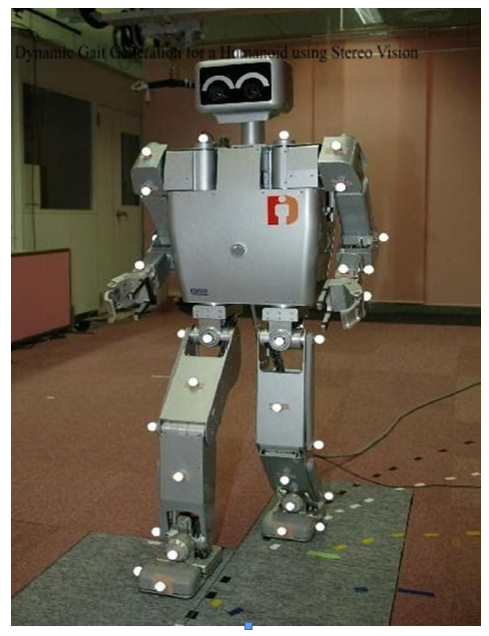

Figure 1.1 Implementation of stereo vision on humanoid

## 

## 1.2 Humanoid Robots of the Future

Dynamic walking, empathizing and grasping an object are some of the hardest problems in robotics that involve trying to replicate things that humans can do easily. The goal has always been to create a general purpose robot rather than a specialized one for specific industrial machines. Here are the six existing robots that point the way towards the humanoid robots of the future.

* + 1. **ASIMO**: Asimo (Advanced Step in Innovative Mobility) was originally built for the Darpa Robotics Challenge. It was developed by Boston Dynamics. The main aim of the ASIMO humanoid is to balance and move

around like a normal human. This is achieved by using AI. Currently, it can be seen displayed in the Miraikan Museum, Tokyo, Japan. [1]

1. **Pepper**: Pepper can serve as a daily companion and a customer assistant. Soft Bank developed it. Pepper makes an effort to identify and give an appropriate response to human emotions. Pepper definitely appears like a robot rather than a human. However, to provide a natural and more intuitive feeling, Pepper uses its body movements and tone of voice. [1]
2. **HRP(Humanoid Robotics Platform)**: HRP robots are available in many versions. HRP-2 was designed and integrated by Kawada Industries, Inc. It is 154 cm tall and has a weight of 58 kg with 30 Degrees of Freedom. The HRP robot is widely used in educational institutions for teaching students the concepts that were used to make this humanoid. HRP-3 was developed as a research and development of platform for the New Energy and Industrial Technology Development Organization (NEDO). It has a better structure and system than HRP-2. It is 160 cm tall and has a weight of 68 kg with 42 Degrees of Freedom. The latest humanoid in HRP series is HRP-4. It is a combination of the main features of HRP-2 and HRP-3. [1]
3. **Nao**: Soft Bank Robotics was instrumental in developing this humanoid. It is of the size of a kid and is 58 cm tall and has a weight of about 4 kg. This humanoid looks very fascinating and it has a brawny structure. Hence, it is also used as a platform to work on. It has 27 Degrees of Freedom. Thus, it is capable of performing yoga asanas. This humanoid has been selected to be given to the RoboCup Standard Platform League contestants [1]
4. **Marty**: This is a very tiny humanoid. ROBOTICAL came up with it. It has got 8 degrees of freedom and is 3D printable. It is also not very difficult to be built. [1]
5. **KHR Kondo series**: This series of humanoids are also small in size. They are mainly used in research. KHR Kondo 2HV and KHR Kondo 3HV are 2 versions which are available. The only difference between the two is that the KHR Kondo 3HV has 2 extra degrees of freedom in its legs. Thus, it can turn with ease. [1]

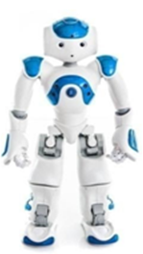

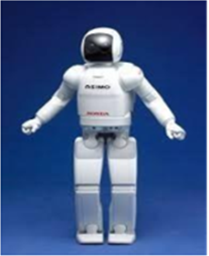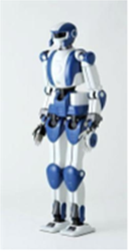

**(a) ASIMO (b) HRP (c) NAO**

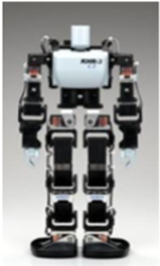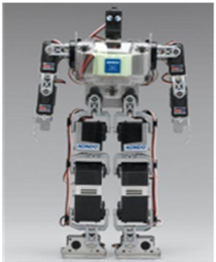

**(d) Marty (e)** Kondo KHR 2HV (f) Kondo KHR 3HV

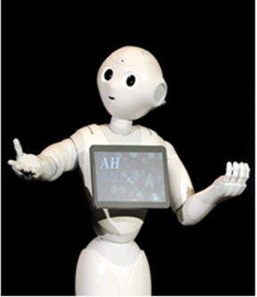

**(g) Pepper**

# PROBLEM STATEMENT

The human walk may be a monotonous process of ‘tilt over’ or unsteady movements that might in some cases cause a sound person to fall down while walking over an uneven surface. The first time the walking process of humans came into the picture was during the First World War while creating replacement legs for impaired workers and soldiers. To mimic a human-like walking trajectory in a humanoid, especially over the inclined and uneven planes, is something challenging and unique when it comes to implementing the cost-effective and dynamic solution.

## 2.1 Motion Planning in Humanoids

The two of the most important features of bipedal humanoid robots are the shape and movements that are very much human-like. The Bipedal humanoid robots consists of two human-like legs. These legs will help the humanoids walk with stability and they should be capability to be on various types of floors such as uneven floors or steps also. Hence, for this reason, numerous researchers throughout the world have studied on bipedal dynamic walking and have come up with many robotic platforms. [7] Two main methods of using motion planners to generate dynamically balanced robotic motions. [8]

* + - * 1. In one of the methods, the humanoid movements are preplanned. The area of the space that needs to be explored can be decided based upon the speed of the humanoid and the position of its footprints.
        2. In another method, a geometric route is decided. The humanoid is supposed to follow this geometric path. In the second step, the geometric path is estimated again.

## 2.2 The Goal

The goal of this project is stated as given below:

‘To develop a dynamic gait generation for a humanoid robot using stereo vision with a capability to walk with small obstacles on an uneven/rough surface as shown in figure 2.2 and to verify using ROS Gazebo environment’.

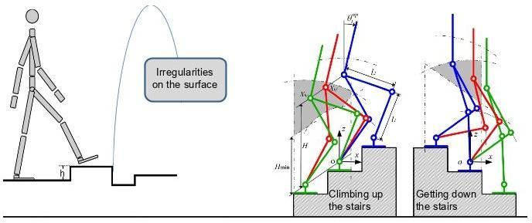

**Figure 2.2 :**Dynamic walking

# LITERATURE SURVEY

This project came in reaction to appreciate dynamic gait for small sized humanoid robots. This process includes utilizing the stereo vision yield (the slant point) as the input to the as of now existing model, so that the pre-planned walks can be self-adjusted such that the humanoid can walk with stability. Zero Minute Point (ZMP) and support polygon play critical parts in guaranteeing the steadiness and stability[1].

## 3.1 Few Definitions

1. **Zero Moment Point**: In static state, a point on the ground is predicted to be the COG based on some calculations. This is the Zero Moment Point or the ZMP. In the dynamic state, the entire force of inertia which comprises of gravity and mass goes though this point. If the ZMP continuously falls within the supporting polygon made by the humanoid feet, it will never fall down. Several research groups use ZMP as a criterion for stable walking of bipedal dynamic walking and the robot is controlled so that the ZMP is maintained within the supporting polygon.
2. **Centre of Mass**: point where the entire mass of the humanoid is concentrated. A point is called center of mass if it moves in the direction of the force without rotating.
3. **Centre of Gravity**: It is the point where the entire weight of the body is assumed to act. It is considered to be equal to the CoM in uniform gravity.
4. **Support Polygon**: Support Polygon is the region formed by enclosing all the contact points of the robot and ground using some elastic cord.

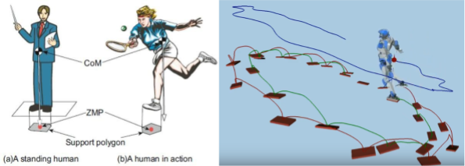

**Fig 3.1** : Image to explain CoM, ZMP and Support Polygon [1]

## 3.2 Inverse Kinematics

Kinematics is the theory which analyses the interrelation between the joint angles and position and attitude of a link [4]. Kinematics lays a basic foundation for robotics. It includes mathematics which deals with rendering a dynamic object in 3D space. If the joint angles are known, and the final orientation of the robot tool tip is calculated, it’s known as Forward Kinematics. If the required position is known and the joint angles need to be calculated, it’s called Inverse Kinematics. Inverse kinematics is a field where the constraints define whether or not the equations are solvable. Hence, the approach in representation of links of a robot decides the effectiveness and solvability of the problem.

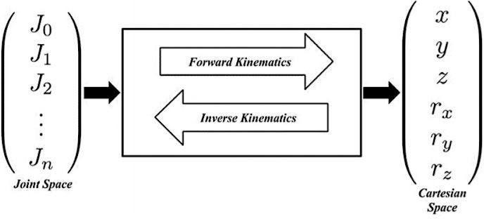

**Figure 3.2**: Description of Forward and Inverse Kinematics

## 3.3 3D Linear Inverted Pendulum Model

3D linear Inverted Pendulum Model is an algorithm to generate a gait pattern that realizes the biped gait by producing a track. A gait pattern is nothing but a set of joint angles to achieve the required gait [1]. The 3D Inverted Pendulum Model consists of a few assumptions. They are listed down below [1]:

* + 1. The entire mass of the robot is concentrated at its center of mass.
    2. It is assumed that the legs of the robot are mass-less. The tips of the leg contact the ground at single rotating joints.
    3. The end of the joint is only capable of moving in a single constrained plane, which has to be parallel to the ground.

The important parameter in the 3D LIP model is R – supporting distance, G – gravity, f- kickforce.

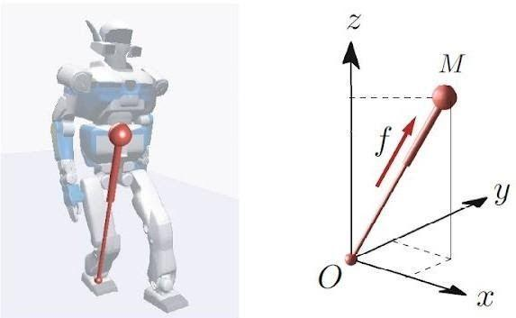

**Figure 3.3(a)**Approximation of a biped humanoid robot as 3D inverted pendulum [1]

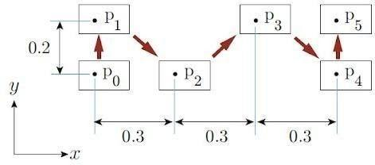

**Figure 3.3 (b) :**foot placements p0 . . . pN from which determine step length and the step width [1]

Since the placements of the humanoid foot are preplanned, we can obtain the position of the end effector directly. Now since we know the position of the end effector and the CoM, the orientation of the rest of the links and can also be estimated easily. Now on applying the theory of inverse kinematics, we will be able to come up with the orientation of the joints throughout the complete span of the humanoid’s locomotion. This will provide us the sequence of angles. The humanoid uses this sequence of angles in order to execute its gait [1].

## 3.4 Gait Planning

The orders of the angles generated above were implemented on the humanoid. The result was successful execution of the gait of the humanoid. The gait was very much like to a human’s gait.

The table below displays humanoid stances at important points during the gait span [1].

|  |  |  |
| --- | --- | --- |
| **Time** | **Side View** | **Front View** |
| **t = 0** |  |  |
| **t = T/4** |  |  |

|  |  |  |
| --- | --- | --- |
| **t = T/2** |  |  |
| **t = 3T/4** |  |  |

|  |  |  |
| --- | --- | --- |
| **t = T** |  |  |

**Table 3.4**: Stances of robot at t=0,T/4,T/2,3T/4 and T [1]

## Simulation Results

Initially, a python simulation was run on the 3D LIP model. The matplotlib package was used to plot the trajectories. The figures below display the simulated plots obtained using python. The figure 3.5 displays the gait that was produced by using the 3D LIP model. This is the entire 3D view of the gaits that were generated. The blue color in the support phase indicates the right leg. Green indicates the left leg green whereas, right leg in swing phase is indicated by red and left leg by yellow [1]. 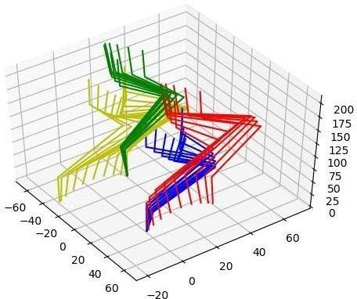

**Figure 3.5**: 3D LIP trajectory [1]

## 3.6 Stereo Vision

In recent times, real-time camera monitoring from distant, isolated applications has had a lot of scope because of its capacity to strictly watch and monitor any place. But, there is a scarcity of realistic view because only 2D images are produced that don’t contain any depth information and natural motion control.

The issue in stereo vision is based on the physical phenomena, that a 3-D object has different projections depending on the point of view. In this manner, it is conceivable to recreate the 3-D scene from at slightest two pictures of the same protest taken from two unmistakably, unique and distinct focuses[2]. Then comparing pixels from one picture are found within the other one and concurring to this data the difference outline is built. Afterward, the 3-D scene is recreated agreeing to the dissimilarity outline. The most complicated issue in stereo computation lies in plan of comparing focuses and points searching metrics and algorithms [2].

Stereo application takes the input as stereo sets of 2-D pictures and produces the recreated 3-D information by finding the comparing focuses. The comparing issue requires a particular looking and coordinating method, the strength of which decides quality and accuracy of reproduced 3-D information .Most stereo recreation strategies are based on the utilization of the pinhole camera demonstration and parallel geometry. In these methods, two points are selected from each of the images, left and right, by using any procedure for stereo matching. Then the depth of the image will be calculated by looking at how inconsistent the two points are from each other(disparity). Depth can also be found by the partition of the two pixel points [2].

As shown in figure 3.6, if (xL, yL) are the pixel coordinate in the left image and (xR, yR) are the pixel coordinates in the right images, then the 3D world coordinates (X,Y,Z) are computed as follows [2] :

**X = xLb/d**

**Y = yLb/d**

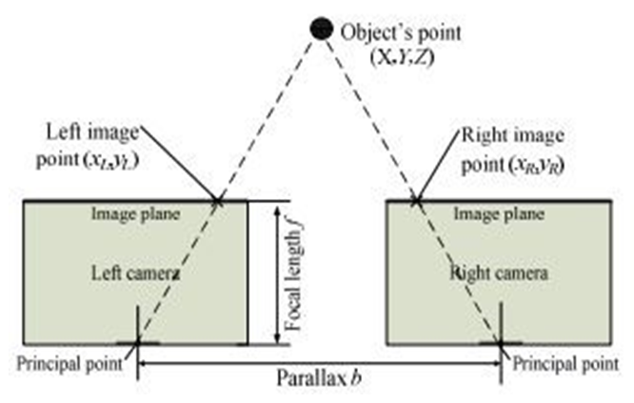**Z = fb/d**

Figure 3.6 **Illustration of Stereo Geometry**

# 4. IMPLEMENTATION USING ROS

In this chapter, we will be telling what has been implemented till now in our simulation and how it can be implemented on hardware. We have used ROS Gazebo for simulating our robots.

## 4.1 ROS Concepts

Robot Operating System (ROS or ros) consists of a group of software frameworks for developing robot software. ROS is not an OS. However, it provides assistance for a mixed computer cluster like functionality implementation, low-level device control, package management, hardware abstraction and message-passing between processes. Running processes in ROS can be depicted in graph architecture. Processing happens in ROS nodes. ROS nodes can get and post information to and from the sensor. It also multiplexes data, messages, state, control, planning etc. Though low latency and reactivity are very vital for robot control, ROS is not RTOS (Real Time Operating System) on its own. But still combining ROS with real-time code is still practical. Given below are some of the important ROS concepts [3].

(a) **ROS Nodes**

ROS Nodes are nothing but processes that are used to execute computations. ROS software has been created in such a way that it can be ROS is designed to be transformable at a fine-grained scale. In general, there are many nodes in a robot control system. Each node will be used to control a particular task. For example, one node might control the gait of the humanoid, one might work to achieve the local maps, one might execute the task of localization and one might execute the task of path planning. Libraries like roscpp and rospy are used to initiate and handle ROS nodes. [3]

(b) **ROS Master**

The lookup to the computation graph and registration is given by the ROS Master. This helps the ROS nodes to find each other, invoke services and exchange messages. [3]

(c) **Parameter Server**

It is a part of the master. It enables data to be stored by a key in a central location. [3]

(d) **Messages**

Messages help the ROS nodes to communicate with each other. A Message can be described as a data structure which comprises of typed fields. ROS Message supports standard types like integer, floating point, Boolean and arrays. [3]

**(e) Topics**

The ROS messages are transported to the ROS nodes through the subscribe/publish semantics. A message is sent by a node by publishing the message to a particular topic. The topic helps to identify the substance of the message. A node that needs to know about a certain kind of data must subscribe to the appropriate topic. Then it gets the required information. [3]

It is possible for many nodes to publish and subscribe for a single topic concurrently. Also a single node can publish and/or subscribe to multiple topics. Generally, publishers and subscribers are not aware of each others' existence. The plan is to keep the production and the consumption of data separate. [3]

A bus helps in sending and receiving messages. A bus is very similar to a ROS topic. A node that wants to communicate must connect to the ROS bus. Then it will be able to send or receive messages. Every bus will be given a particular name. [3]

**(f) Services**

The publish / subscribe model is makes the communication among the ROS nodes very flexible. But for a distributed system to communicate efficiently, a one way system connecting many parts would not be sufficient and appropriate. A reply or a request can be sent or received by using the ROS services. In ROS, there are two kinds of structures for messages. One message structure for reply and one for request. The node that requires any kind of service will send a request message and waits for the reply. A node that is ready to offer any kind of service provides the service under a name. The programmer or the user accesses this interaction in the form of a remote procedure call. This job is again done by the ROS libraries [3].

(g) **Bags**

There is also a requirement for storing and playing data, messages etc. ROS bag only provide a format for this purpose. This format is needed since it can be very tedious to collect all the data and store them. However, this data would be needed to test and run algorithms. [3]

## 4.2 About HRP-4

We carried out our simulation by importing HRP-4 robot in the ROS Gazebo environment. The most recent model in the HRP series is the HRP-4 humanoid. It is also one of the most advanced humanoid all thanks to the deep rooted partnership between Kawada industries. Kawada industries are led by Tadahiro Kawada, and Japan's National Institute of Advanced Industrial Science and Technology (AIST), headed by Tamotsu Nomakuch. HRP-2 was developed in 2002. HRP-3 then was developed in 2006. After this, HRP-4 was developed. The aim of this project was to make the humanoid more light weight and hence secure for human interactions. In this project, engineers from Kawada focused on the humanoid robot hardware while the AIST researchers

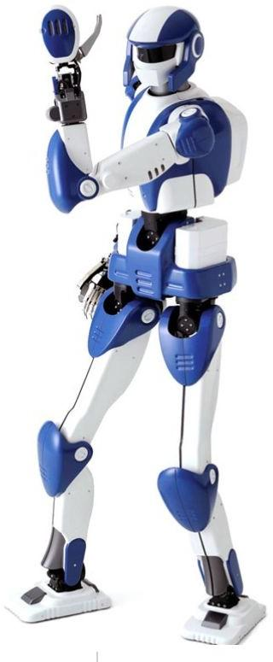

**Figure 4.2:** HRP-4 Humanoid [4]

developed the motion-control software. The goal was to make the new humanoid convenient and lighter making it safer for human interaction. But HRP-4 was created with aim to make it more capable than HRP-2 and HRP-3 humanoids in terms of manipulating objects and navigating human environments. It was made sure that this objective was fulfilled. The final design was unveiled in September 2010. [4]

HRP-4 is one of the world's most advanced humanoids, the result of a decade of R&D. It's designed to collaborate with humans and can perform remarkably natural, human-like movements. [4]

**Table 4.1 Specifications for HRP-4 [4]**

|  |  |
| --- | --- |
| Created by | **Kawada Industries and AIST** |
| Country | Japan |
| Year | 2010 |
| Type | Humanoids, Research |
| Features | Compact, lightweight design. Able to lift  0.5 kg (1.1 lb) with each arm. Equipped with low-power motors for improved safety. |
| Height | 151 cm | 59.4 in |
| Weight | 39 kg | 86 lb |
| Sensors | Cameras (in the head and arms),  microphones. |
| Actuators | 80-W motors and lower power motors |
| Computing | PC/104 Pentium M computer with Wi-Fi  and speakers. |
| Software | Linux OS with RT-PreemptPatch and  OpenRTM-aist middleware. |
| Degrees Of Freedom (DOF) | 34 (Leg: 6 DoF x 2; Neck: 2 DoF; Chest: 2  DoF; Arm: 7 DoF x 2; Hand: 2 DoF x 2) |
| Materials | Plastic covers, aluminum alloy frame. |
| Official Name | HRP - 4 |

* 1. **4.3 ROS Gazebo**

Gazebo allows us to view the actions of the humanoid in a 3D scenario on your computer. It provides the robots, obstacles and many other objects that will be required to carry out the simulation. Gazebo uses a physical engine for illumination, gravity, inertia, etc [5]. So the robot or the humanoid can be assessed and tested during risky tasks without any harm to the robot in the real world hence minimizing the damage. Apart from this, it takes much lesser time to run a simulation instead of starting the whole scenario on your robot in the real world.

Actually Gazebo was designed to address the problem of testing the algorithms on

the robots. During a lot of times, it is crucial to evaluate your robot application, for various activities such as battery life, navigation ,grasping, error handling and localization. Since simulating the robot was a priority, Gazebo was produced and then later improved. [5]

## 4.4 Our Simulation

1. In ROS Gazebo, we have imported the rospy library that helps us to execute all the ROS related commands in Python.
2. There is a ROS node that is connected to all the leg joints. We know that ROS nodes connect the external environment to the humanoid and vice versa. Here the external environment is python. In the python code, the servo angles are being calculated. These servo angles are given as input to the humanoid with the help of ROS nodes.
3. There is a stereo vision camera sensor that has been attached to it. Hence, now the robot can perceive its surroundings. There is a cuboid that is kept in front of the humanoid. When the robot nears it, the robot calculates its slope and raises its leg to place it on the cuboid.
4. For calculating the slope, a simple equation tan^-1((y2-y1)/(x2-x1)) has been used. Here x1, y1 are the coordinates of the lower rectangle and x2,y2 are the coordinates of the higher rectangle. The slope is calculated using this equation and the servo motors are adjusted accordingly.
5. So on perceiving the obstacles and while walking on unsmooth surfaces the robot plans its gaits accordingly and walks.

**Figure 4.4:** Screenshot from the simulation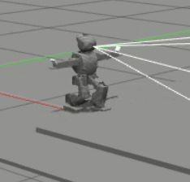

## 4.5 Hardware Implementation

1. The humanoid on which our logic will be implemented will have a stereo vision camera sensor attached to it. The camera provides the image data to the humanoid that is used for object identification, tracking and manipulation tasks. Hence this allows the humanoid to sense the obstacles around it and gets familiar with the environment. It computes its distance from the obstacles with respect to its own frame.
2. When the x, y coordinates of the obstacles are found then the slope are also calculated. This is given to the raspberry pi where the servo angles are calculated.
3. After the angles are calculated, they are given as inputs to the Arduino.
4. The Arduino in turn, controls the servos and the humanoid adjusts its gaits and starts moving with stability.

This is how the logic has been successfully implemented on hardware.

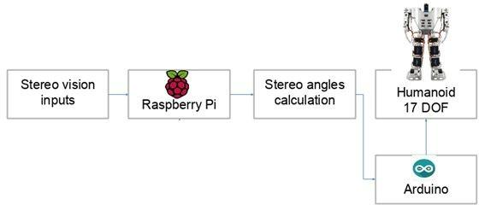

**Figure 4.5 :** Working of Dynamic Walking on Hardware

# RESULTS AND DISCUSSION

Initially, the robot would fall whenever it would come across an obstacle since it was following a pre planned gait. On attaching the camera sensor, the robot was able to get a knowledge about its local environment. Hence it was also able to find the coordinates of the cuboids that were placed in front of it. Using these coordinates, it computed the slope.

Accordingly, the joints and the servo motors of the humanoid were adjusted dynamically without any human intervention preventing the humanoid from falling down.

The generated gaits were tested on the imported humanoid model in ROS Gazebo. Whenever the robot moves from a lower step to a higher step, the slope is calculated and is displayed on the terminal as shown in the image above, thus allowing the robot to walk on unsmooth surfaces. The robot performed to match the expectations.

Figure 5.1 provides a glimpse of our implementation where the humanoid has successfully computed the slope and performed dynamic gait according to its calculations.

The main operations that were performed on the robot were, walking forward, turn left and right and also it was capable of walking on slopes and stairs.

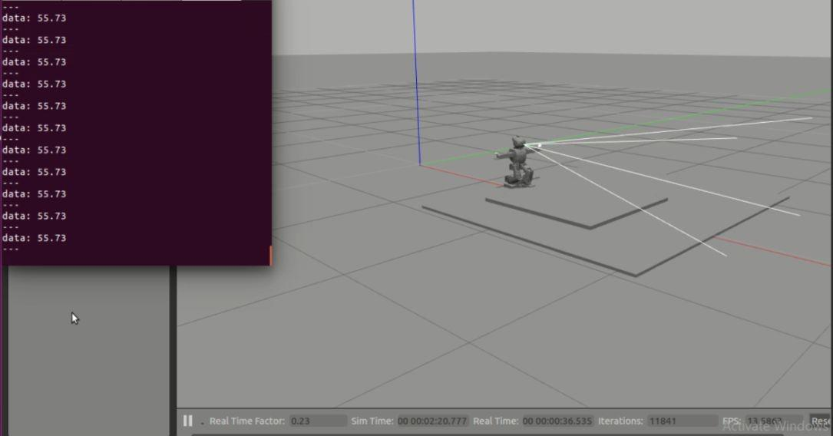

**Figure 5.1:** Simulation using the HRP-4 humanoid in ROS

The logic has been successfully implemented on ROS Gazebo. This can be further implemented on the hardware as well.

We have come across the following hurdles during the entire course of this simulation:

1. Finding a suitable model for our project consumed quite a lot of time. We went through many websites and searched upon the specifications and features of various humanoids. Finally, HRP-4 consisted of the features and specifications that were needed for our simulation.
2. Finding a ROS version that was compatible for our system and OS was a tedious task.

We encountered a lot of errors while installing ROS Kinetic, as the system was bound to low-graphics mode.

1. Learning ROS and writing the python code in ROS was also very important. It required a little brain storming to come up with a suitable code for a proper simulation by making use of the ROS concepts.

The results were obtained by using a single camera sensor. However, this can be extended to a stereo system also and can be implemented successfully using depth mapping, occupancy grids and localization algorithms.

# CONCLUSION

A noteworthy advance has been made towards steady mechanical and robotic bipedal walking, thus resulting in a big and interesting query about creating an independent route navigation methodologies custom-made particularly to humanoid robots. The capacity of the bipedal, humanoid robots to not only move around an obstacle but also to be able to walk over a few deterrents makes them apt for terrains and surfaces planned for the humans that frequently consist of a wide mix of objects and deterrents like furniture, entryways , stairs, and uneven ground. If the humanoid should be able to navigate and explore its environment with liberty, without any thought of falling down anywhere, it should be able to visualize the environment that it is present in from the information it receives from its sensors. Using this data, the route can be developed. So, in order to create the gait that will make the humanoid reach a destination, the robot’s environment should be available to it in the form of global maps. This results in more productivity. In any case, on-body perception is solely restricted in extent and course. Some approaches have focused on retrieving the information about the local environment that the humanoid is currently in. This only enables a few strategies for navigation such as reactive obstacle avoidance to be implemented. Some other approaches have used off-body visual sensing in order to compute the global maps. However the latter approach sacrifices some level of liberty of the robot. Through this approach, barriers like parallax and occlusions can be found.

Further study will focus on addition of toes to robot’s foot and make it counteract the disturbances and use of an on-board computer for real time generation of sequences to get more realistic walk on this humanoid, TONY. The scope of possibilities for future work on the humanoid is endless and there are multiple ways of improvement in the robot whether be it improving the automatic gait-generating algorithm to upgrading the hardware.

# REFERENCES

[1] “Solving inverse kinematics using geometric analysis for gait generation in small sized humanoid robots”, Prasanna Venkatesan, Prajwal Rajendra M, M Rajasekar.

[2] “Using real-time stereo vision for mobile robot navigation”, Don Murray & James J. Little.

[3] http://library.isr.ist.utl.pt/docs/roswiki/ROS(2f)Concepts.html

[4] https://robots.ieee.org/robots/hrp4/ [5]

https://www.generationrobots.com/blog/en/robotic-simulation-scenarios-with-gazebo-and-ros

[/](https://www.generationrobots.com/blog/en/robotic-simulation-scenarios-with-gazebo-and-ros/)

[6] “Walking Control Algorithm of Biped Humanoid Robot on Uneven and Inclined Floor”, Jung-Yup Kim, Ill-Woo Park and Jun-Ho Oh.

[7] “Experimental realization of dynamic walking of the biped humanoid robot KHR-2 using zero moment point feedback and inertial measurement”, [Jung-Yup Kim](https://www.tandfonline.com/author/Kim%2C+Jung-Yup),[Ill-Woo Park](https://www.tandfonline.com/author/Park%2C+Ill-Woo) &[Jun-Ho Oh](https://www.tandfonline.com/author/Oh%2C+Jun-Ho)

[8] “Dynamic Walking and Whole-Body Motion Planning for Humanoid Robots: an Integrated Approach”, Sébastien Dalibard, Antonio El Khoury

# APPENDIX

1. Python code for slope calculation

#!/usr/bin/env python  
  
import rospy  
from std_msgs.msg import Float64  
from gazebo_msgs.msg import ModelStates  
import math  
  
class Angle(object):  
    def __init__(self):  
            self.angle = 0  
            rospy.Subscriber("/gazebo/model_states", ModelStates, self.angle_detect)  
            self.pub = rospy.Publisher('angle_detected', Float64, queue_size=10)  
  
    def angle_detect(self, data):  
        if(data.pose[3].position.x > 1.14 and data.pose[3].position.x < 1.3):  
            self.angle = math.atan(data.pose[3].position.y/data.pose[3].position.y) #angle value in

radians

 self.angle = math.degrees(self.angle)      # self.angle value is in degrees          
            self.pub.publish(self.angle)  
        elif(data.pose[3].position.x > 1.5 and data.pose[3].position.x < 2):          
            self.angle = math.atan(data.pose[3].position.y/data.pose[3].position.y) # self.angle value is in radians  
   self.angle = math.degrees(self.angle)      # self.angle value is in degrees  
            self.pub.publish(self.angle)  
        else:  
            self.angle = 0

def spin(self):  
        print(self.angle)  
        while not rospy.is_shutdown:  
            self.pub.publish(self.angle)  
            rate.sleep()  
  
  
def main():  
    rospy.init_node("angle_detector")  
    node = Angle()  
    rospy.spin()  
  
  
if __name__ == '__main__':  
    main()